Lab 10

**Part 1 - Sending values to a script Pg 306**

1. We will be modifying **view_users.php** (script 9.6) file that we created in lab 9 to send values to a php script. The new script will still be called **view_users.php,** but it will now be referred to in the text as script 10.1.
2. Follow the steps 1-5 on page 306 - 309. This will add the links for the functions that we will be creating in Parts 2 and 3 of this lab.
3. Table

   Description automatically generated**Screenshot the results of the view_users.php file**

**Part 2 - Using Hidden Form Inputs Pg 310**

1. Follow steps 1 - 16 on pages 310 - 315
2. You added me to your database in lab 9. Delete me from your database by clicking the delete link under the **View Users** tab in your website. Feel free to delete someone else if you don't have me in your database.
3. Graphical user interface, text, application

   Description automatically generatedIt will ask you to confirm. Select Yes. **Make a screenshot before you hit the submit button.**
4. The browser will display the confirmation that I was deleted. **Screenshot this also.**

**Part 3 - Editing Existing Records Pg 316**

1. Follow the steps 1 - 17 on pages 316 - 322
2. Edit any user. Change the user email to a different email.
3. 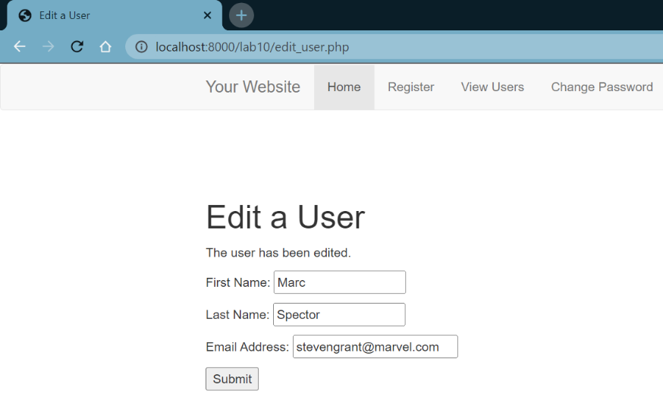**Screenshot the result.**

**Part 4 - Paginating Query Results Pg. 323**

1. Follow the steps  1 - 20 on pages 323 - 330. This will make the database paginate the results. (Script 10.4)
2. Click on the View Users tab
3. Table

   Description automatically generated**Screenshot the results.**

**Part 5 - Making Sortable Displays Pg. 331**

1. Follow steps 1 - 8 on pages 331 - 335 to make the updated **view_users.php** page in the previous part of the lab, be searchable as well.
2. Table

   Description automatically generatedSort the database by last name, then first name, then by registration date by clicking on the field headers. **Screenshot the results of each.**

